


INDIVIDUAL ASSIGNMENT

LANKA

COMP40004

WEB DEVELOPMENT AND OPERATING SYSTEMS-1
COMK2461

HAND OUT DATE: 15th July 2024

HAND IN DATE: ASSIGNMENT2: 13th September 2024

WEIGHTAGE: ASSIGNMENT 2: 30%

INSTRUCTION TO CANDIDATES:

- Students are advised to underpin their answers with the use of references (cited using the Harvard Name System of Referencing).

- Late submission will be awarded zero (0) unless Extenuating Circumstances (EC) are upheld.

- Cases of plagiarism will be penalized

- Assignment presentation should be submitted in the form of softcopy and hardcopy both; modeling work should be submitted in softcopy form

INDIVIDUAL ASSIGNMENT

WEB DEVELOPMENT AND OPERATING SYSTEMS-1
COMK2461

Name: Ahmed Zayn Mohamed Zareer

CB Number: CB 01 6024

Date:

Contents

Contents
Contents
Contents 3
Acknowledgment 3
1.0 Wireframes 5
1.1 Desktop Wireframes 5
1.2 Mobile Wireframes 9
2. Challenges faced 12
3. Solutions 13
4. References 14

Acknowledgment

I would like to express my gratitude to our lecturer Mr. Pradeep Pallegama who helped us get a good understanding of the module and guided us through the WDOS 1 assignment.

Furthermore, I would like to thank my fellow colleagues who helped me out throughout this assignment.

Wireframes

1.1 Desktop Wireframes

Home page

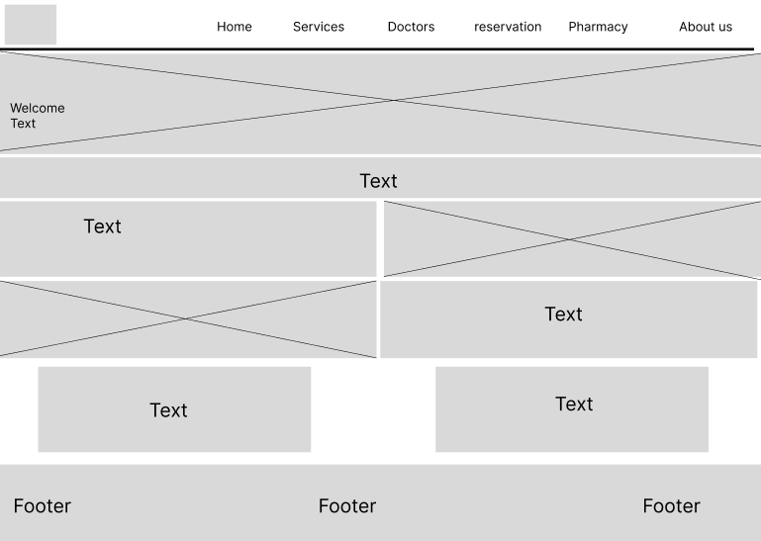

Services Page

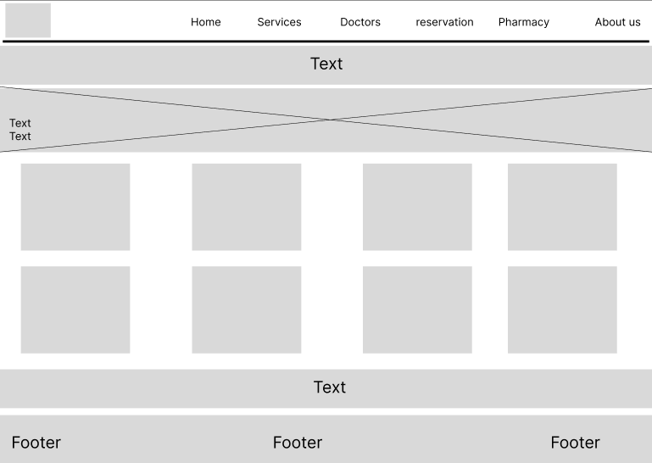

Doctor’s Page

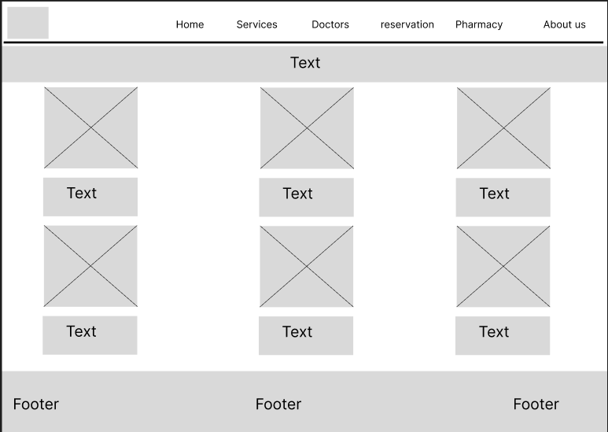

Doctor Reservation page

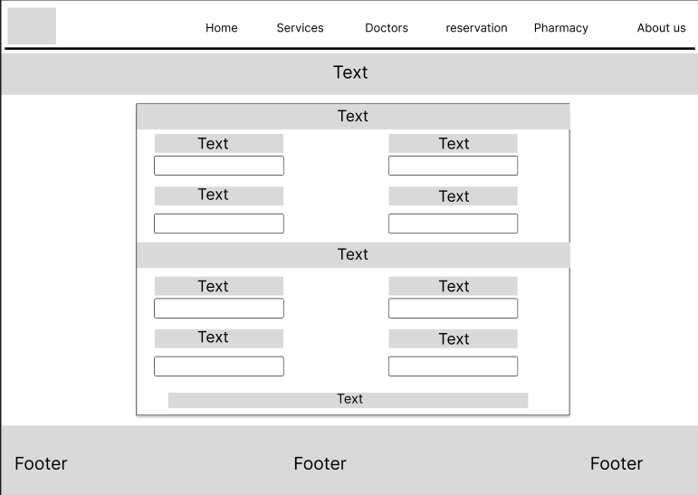

Pharmacy page

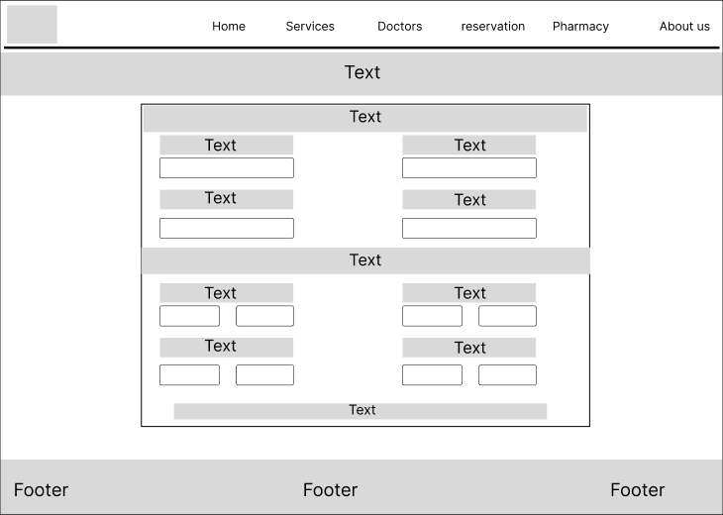
About us page

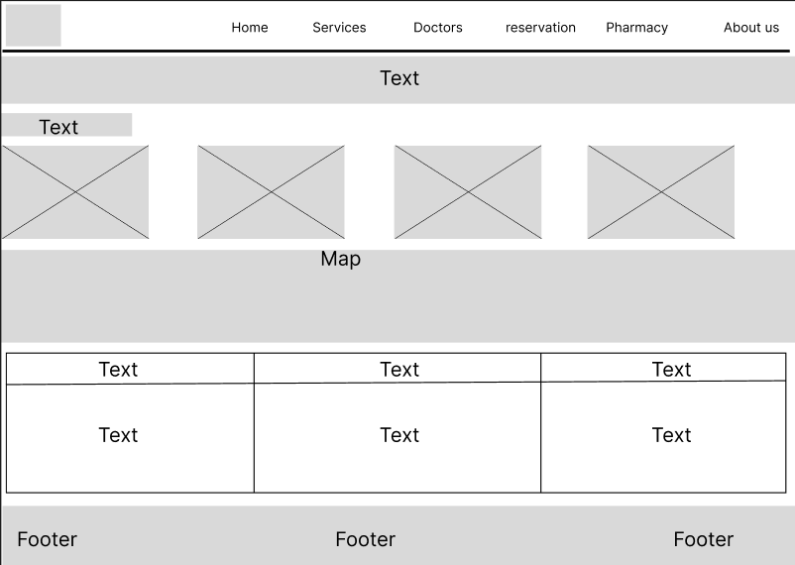

1.2 Mobile Wireframes

Home page

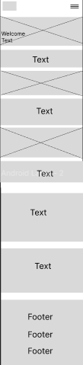

Services page

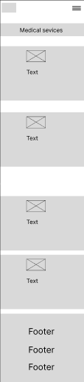

Doctor’s Page

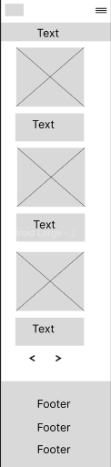

Consulting Reservation page

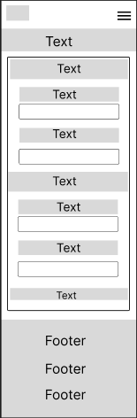

Pharmacy page

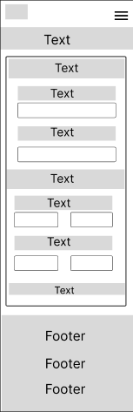

About us page

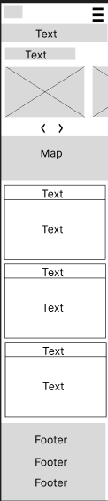

2. Challenges faced

I faced multiple challenges throughout my webpage designing. Here are a few of them:

- I had issues with placing my welcome text on top of the main image in the home pages. The text was appearing outside the image. Using div elements did not solve the issue either.

- One of the problems I had with the CSS styling of the webpage was with animations and transitions. I had limited knowledge of the properties, and therefore struggled to create the animations that I wanted and did not know how to style some of the animation ideas that I had.

3. Solutions

- The text over image issue was solved after learning the ‘position: relative’ and the ‘position: absolute;’ properties in CSS. I was able to set the main image to ‘position: relative’ and the text div to ‘position: absolute’. Thereafter I was able to style the text div element relative to the image and place it where I wanted using the ‘top’, ‘left’, ‘rights’ css properties.

- The animation challenges were dealt with by browsing YouTube and the internet for guides on animations and transformations in CSS. After building a basic idea on those, I was able to apply animations with ease. Though I did not come a pro at it, the basic knowledge cleared a lot of doubts I had and now I have the basic idea on adding animations and transitions. So learning the advanced methods will be much easier.

References

- CodingLab 2021, Responsive Registration Form in HTML & CSS, YouTube 5 Jan, viewed August 20 2024. https://youtube.com/watch?v=okbByPWS1Xc&si=vq8ZYdPA5RZ3bJtU
- CodingLab 2023, Button Click Animation in HTML & CSS, YouTube 10 Jan, viewed August 21 2024. (https://youtube.com/shorts/ff4QjmWh1Hk?si=9kyEMlmiLqjs1Oc8)
- SnippetsCode 2024, Animate On Scroll With Just 3 LINES Of CSS(No Libraries Needed), YouTube 2 Jun, viewed August 20 2024. (https://youtu.be/0TnO1GzKWPc?si=NqwgbgqKvNbPbNi3)
- Children’s National Hospital 2024, Children’s National Hospital, Children’s National Hospital, viewed August 21 2024. (https://international.childrensnational.org)
- Northwestern Medicine (2024). Doctor Search Results | Northwestern Medicine. [online] Northwestern Medicine, viewed 23 Aug. 2024.
(https://www.nm.org/doctors/search-results)

